Property Agent List
SN | Business Name | First Name | Last Name | Business Facility Name | Contact details | Street Address | Email | Password | Photo
1 |  | Ebuka | Okeoma | Splendid Homes | 08112963732 | 79 Ogunlana drive Surulere Lagos | Ebuka.okeoma@yahoo.com | #EbukaOkeoma | 
2 |  | Moyin | Olagoke |  | 08168518518
3 | Balosisqo Properties |  |  | Balosisqo Properties | 08052879550, 08037041787 | Anthony Village |  | #BalosisqoProperties | 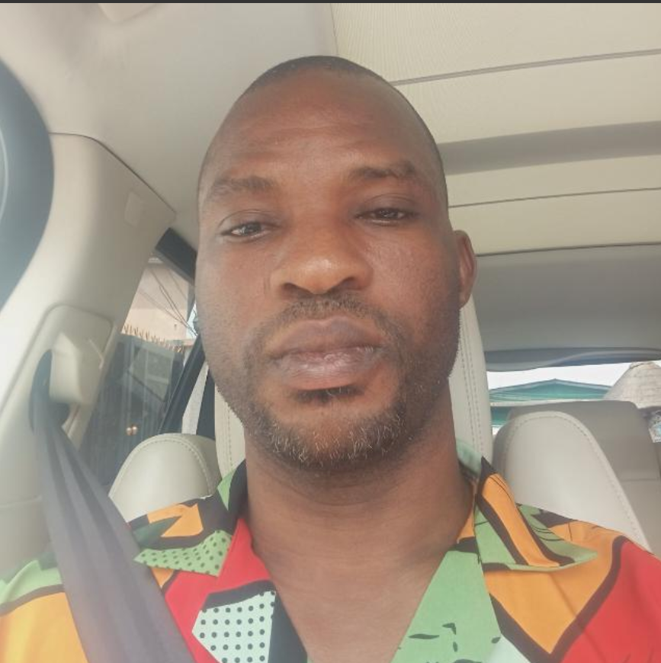
4 | HARRIS CONSULT REALTY |  |  | HARRIS CONSULT REALTY | +234 703 860 0757 | Ikeja, Lagos |  |  | 
5 |  | Funmilola | Ayoade |  | +234 802 887 2081 | Ikeja, Lagos |  |  | 
6 | ~Ponmile (PM) Real Estate agents |  |  | ~Ponmile (PM) Real Estate agents | +234 901 242 1746 | Ejigbo, Lagos | ponmilerealestateagent71@gmail.com |  | 
7 | Seamless Property Solutions And Investment Ltd |  |  | Seamless Property Solutions And Investment Ltd | "+2348161638534, +2348074360152, +2348161638534 | Suite 124 Ikota Complex, Vgc Ajah Lagos, Ajah, Lagos, Nigeria | http://www.propertysolutions.com.ng/ |  | 
8 | Obic-homes Property |  |  | Obic-homes Property | 07026553153, 07026553153, 07026055947, 08136360580 | Chevron Alternative, Lagos, Lagos, Nigeria
9 | EM Global Vnetures |  |  | EM Global Vnetures | 08034134917, 08034134917 | Suit 204 Pearl Plaze, Ajah. Lekki, Ajah, Lagos, Nig
10 | 2702assets |  |  | 2702assets | 09038289966, 09038289966, 09038289966, 09038289966 | 15,buraimo Alli Lady Lak Gbagada, Gbagada, Lagos State, Nigeria |  |  |     
11 | 12 Pearls Ventures |  |  | 12 Pearls Ventures | 08056378528, 07041118876 | 203 Igbosere Road, Lagos Island , Lagos, Nigeria | https://12pearls.estateagentsng.com
12 | 360 Properties |  |  | 360 Properties | 07057125752, 08033648310 | 10 Oregun Road, Oregun, Ikeja, Lagos, Nigeria | https://www.360properties.ng
13 | Didi Cole Limited |  |  | Didi Cole Limited | 07070076014, 07036256952, 07070076014, 08178417990 | H62, Ikota Shopping Complex, Victoria Garden City, Ajah, Lagos, Nigeria | https://DidiCole.estateagentsng.com | 
14 | Dipaking And Company Limited |  |  | Dipaking And Company Limited | 08039643562, 08039643562, 08039643562 | 10, Olaribiro Street, Off Allen Avenue, Ikeja, Lagos, Nigeria | https://dipakinghomes.ng/
15 | Diplomacy Homes And Properties |  |  | Diplomacy Homes And Properties | 08028388567, 08035110800 | Block D3, Suite 41, Olugbede Model Market, Egbeda, Alimosho Lga, Lagos, Nigeria | https://diplomacyhomes.estateagentsng.com |  | 
16 | Enokfem Nigeria Limited |  |  | Enokfem Nigeria Limited | 08060346428, 08052951513, 09135562898 | 53, Ijaye Road, Ogba, Ikeja, Lagos, Nigeria | https://enokfem.estateagentsng.com | 
17 | Ericity Properties |  |  | Ericity Properties | 2.34707E+12 | Block C21, Joygood Mall, Opposite Fara Park Estate, Off Lekki Epe Expressway, Ibeju Lekki, Lagos, Nigeria | https://ericitypro.estateagentsng.com
18 | Fta Global Resources Nig Ltd |  |  | Fta Global Resources Nig Ltd | 08132375831, 08059421682 | Mulliner Tower, Old Nnpc, 39 Afred Rewane Road, Ikoyi, Lagos, Nigeria | https://ftaglobalresources.estateagentsng.com |  | 
19 | Future Homes Properties And Investment Ltd |  |  | Future Homes Properties And Investment Ltd | 07088065449, 08163742693 | 8 Providence Road, Lekki, Lagos, Nigeria | https://futurehomeproperties.estateagentsng.com
20 | Williams & Partners Limited |  |  | Williams & Partners Limited | 016327343, 07046069383, 08125823422, 09013500489 | 16 Amodu Ojikutu Street, Victoria Island, Lagos, Nigeria | https://williamsandpartners.estateagentsng.com | 

